Project Management

Directions
Complete the simulation found on the Assignment Manager page on the Pearson site.

Suggestions
- For each activity, calculate the cost to expedite/crash each day
- Look at the critical path activities first
  - Obsessively obsess over the critical path
- Save some money for unplanned events during the building process

Questions
- What were the following results for the completed project?
  - Project cost
    - $162,199.00
  - Project profit/loss in $ and %
    - $17,801.00
  - Project completion time
    - 126
  - Project status (days over/under)
    - +1 day
  - Decision accuracy
    - Medium
- What was the original critical path? How did it change as tasks were expedited/crashed?
  - The original critical path got stuck up on framing, and painting, however after these processes switched to better contractors or were expedited, I was able to increase the speed of the project.
- How was it decided which tasks to expedite/crash?
  - Tasks which made up a part of the critical path were all evaluated to find the best value in number of days saved for the money.
- What was the homeowner morale? What factors impacted this?
  - Homeowner morale was the representation of how on time I was. Since most of the project up until the end was ahead of schedule, my morale was fairly high.
- Were the goals reached for the simulation? If not, how could it have been improved? If yes, then what was done that led to the success?
  - I think the goals were reached for the simulation. I was able to produce the product near the time expected for near the cost I had expected.

Overview


Summary Screen
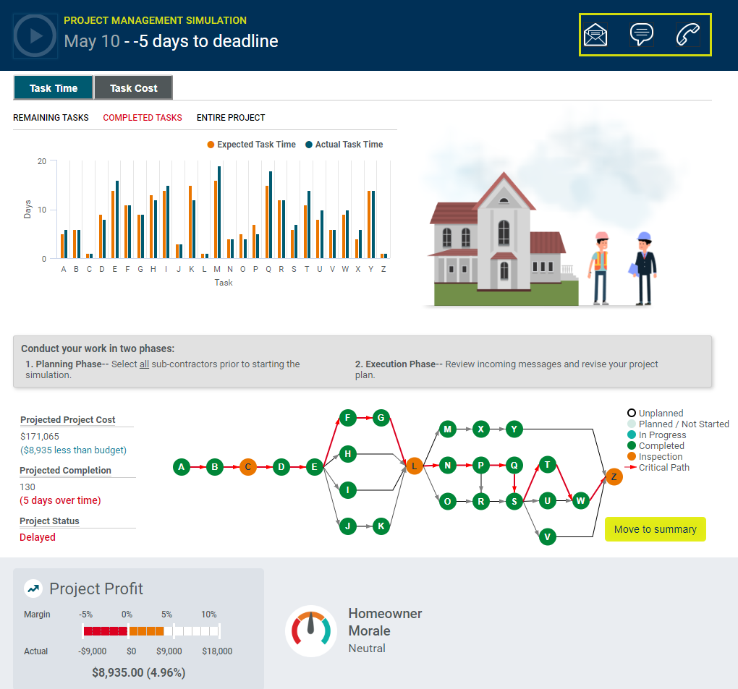

Results – General Feedback
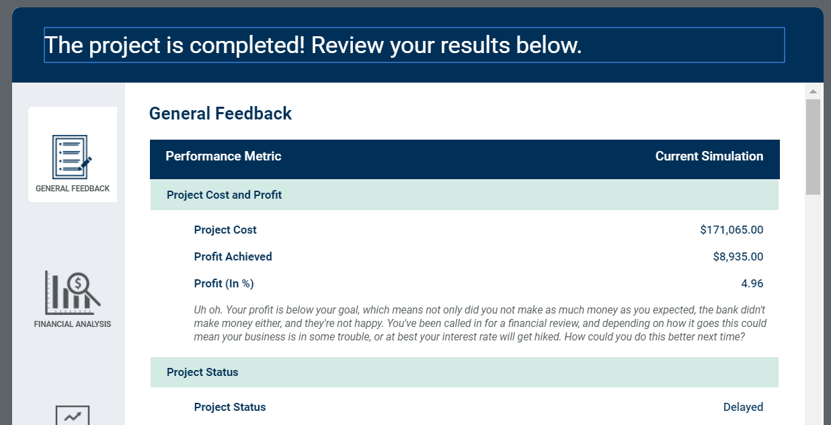
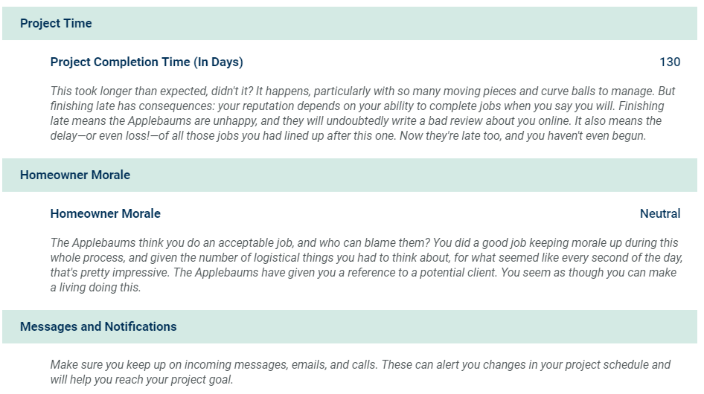

Financial Analysis
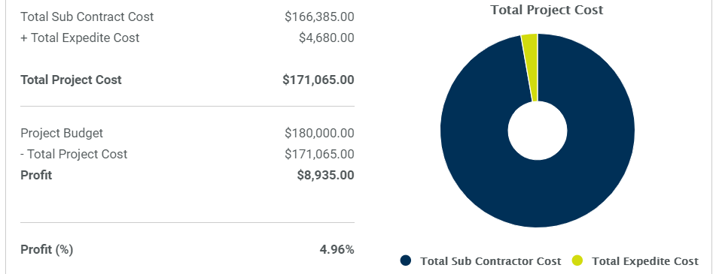
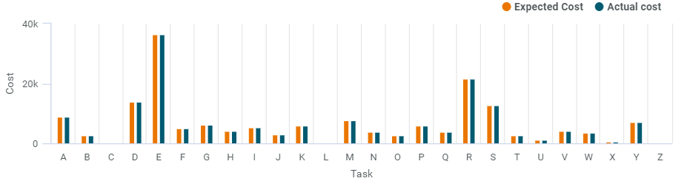

Decision Analysis
